**Open radarWaveformAnalyzer App**

When you type radarWaveformAnalyzer from the command line or select the app from the **App Toolstrip**, an interactive window opens. The default window shows a rectangular waveform and its spectrum. You can then select various options to analyze different waveforms.

radarWaveformAnalyzer

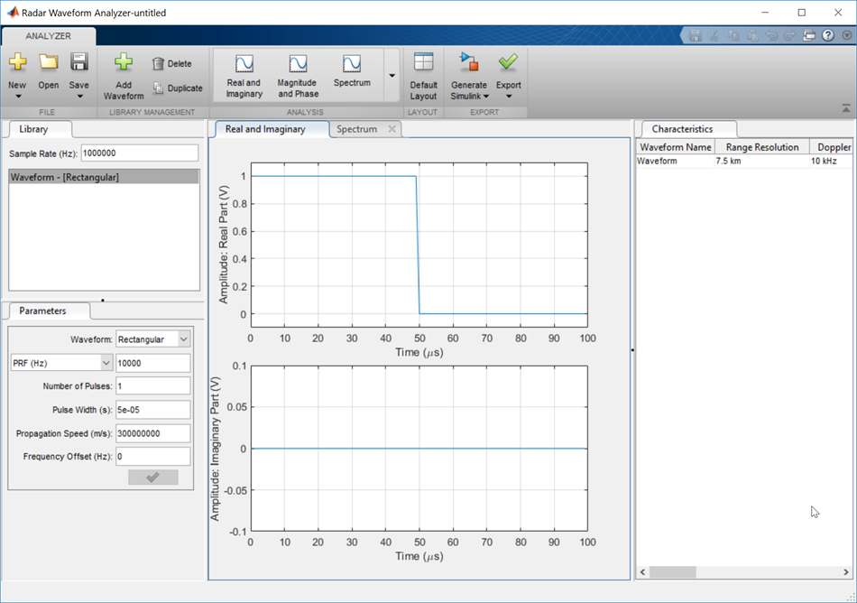

**Show the spectrogram of baseband FMCW signal**

As an example, use the app to show the spectrogram of a continuous FMCW waveform.

1. Set the **Waveform** to FMCW
2. Set the **Sweep Interval** to Symmetric
3. Set the **Number of Sweeps** to 4
4. In the **Analysis** tab, select Spectrogram

Then, you will see a plot of the spectrogram of the signal similar to this.

